H.T No
Regulations:
A15


Sreenidhi Institute of Science and Technology
(An Autonomous Institution)
Code No:5AC07 Date: 30-Jan-2020 (FN)

B.Tech II-Year II-Semester External Examination, Jan/Feb - 2020 (Supplementary)
CONTROL SYSTEMS (EEE)

Time: 3 Hours Max.Marks:75

Note: a) No additional answer sheets will be provided.
b) All sub-parts of a question must be answered at one place only, otherwise it will not be valued.
c) Missing data can be assumed suitably.

Part - A Max.Marks:25

Answer all QUESTIONS.

1. | Give the examples of open loop control systems. | [3M]
2. | What is PID controller? Write the transfer function of PID controller. | [3M]
3. | How the root locus is affected by adding zeros to transfer function. | [3M]
4. | How do you define stability from bode plot point of view? | [3M]
5. | Explain the Nyquist stability criterion. | [3M]
6. | Define state equation and draw the state diagram. | [2M]
7. | Explain Mason’s gain formula. | [2M]
8. | Define Gain margin and give its formula? | [2M]
9. | Draw the Lag compensator diagram. | [2M]
10. | What are standard test signals? | [2M]
Part – B Max.Marks:50
ANSWER ANY FIVE QUESTIONS. EACH QUESTION CARRIES 10 MARKS.

11. | a) | Find the transfer function Y(s)/R(s) for the block diagram shown in Fig.2.  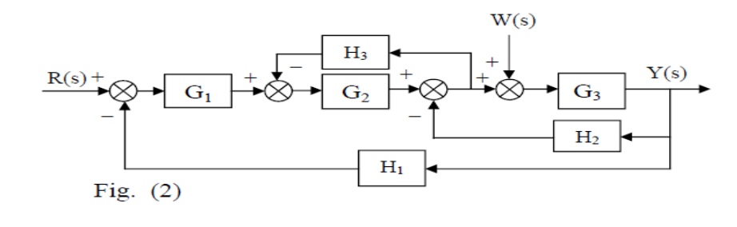 | [5M]
 | b) | Verify the above transfer function with masons gain formula. | [5M]
12. |  | Derive the transient response for standard second order system when it is subjected to unit step input. | [10M]
13. |  | Sketch the root locus for the unity feedback system shown in below figure?.  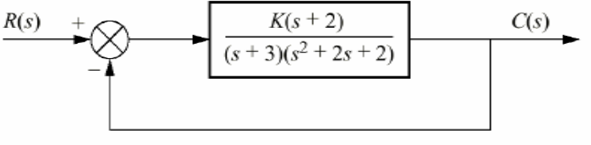 | [10M]
14. |  | Draw the bode magnitude and phase angle plot for the loop transfer function  G(s) = 50(s + 2)(s + 3)/ (s + 1) | [10M]
15. |  | Given the system  G(s) = 10 /(s ² + s + 9)  Plot the Nyquist diagram and determine exactly the phase margin, PM? | [10M]
16. |  | Find the state transition matrix for the system given by  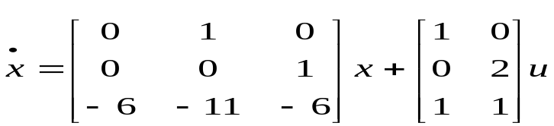 | [10M]
17. | a) | Give different classifications of control systems. | [3M]
 | b) | What are different static error constants? | [3M]
 | c) | Describe the limitations of R-H criterion. | [4M]
18. | a) | Explain various frequency domain specifications. | [3M]
 | b) | Demonstrate about Lead-Lag compensation. | [3M]
 | c) | Explain the diagonalization with suitable matrix. | [4M]

-- 00 -- 00 –

